

DRAFT
Technical Specification

Melbourne IT OFC
OFC Pending Internet Expenses Report

Author: Tony Whelan
Creation Date: 15 June 2016
Last Updated: 15 June 2016
Version: 1.0
Table of Contents

1. Requirement 3
2. Solution Overview 3
3. Technical Objects 4
3.1 BI Publisher XML Data Definition File 4
3.2 BI Publisher RTF Report Template 4
4. Configuration 4
4.1 Define Concurrent Program 4
4.2 Define XML Data Definition 5
4.3 Define XML Template 5
4.4 Update Concurrent Program 6
4.5 Update Request Group 6
5. Report Execution 7

Requirement

Melbourne IT have a requirement for a Pending Internet Expenses Report listing details of all Internet Expense Reports with an expense status code of Pending Manager Approval, Pending User or Error.

Solution Overview

This document describes the configuration and execution of XML Report MEL IT Internet Expenses Pending Report to provide the above information.

Technical Objects

BI Publisher XML Data Definition File
This file contains the SQL query, data elements and parameters for the report.


BI Publisher RTF Report Template
This file contains the xml markup and report layout definition for the report.


Configuration

Define Concurrent Program
Responsibility: System Administrator
Menu Path: Concurrent -> Program -> Define
Form: Concurrent Program
Purpose: Define a new concurrent program.

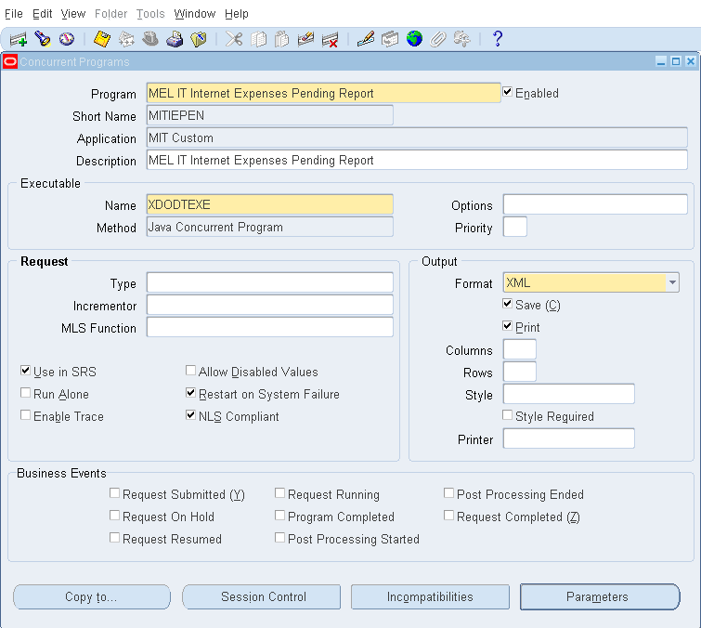

Define XML Data Definition
Responsibility: XML Publisher
Menu Path: Home -> Data Definitions
Form: Data Definition
Purpose: Define the Data Definition in XML Publisher; attach the XML Data Definition file.

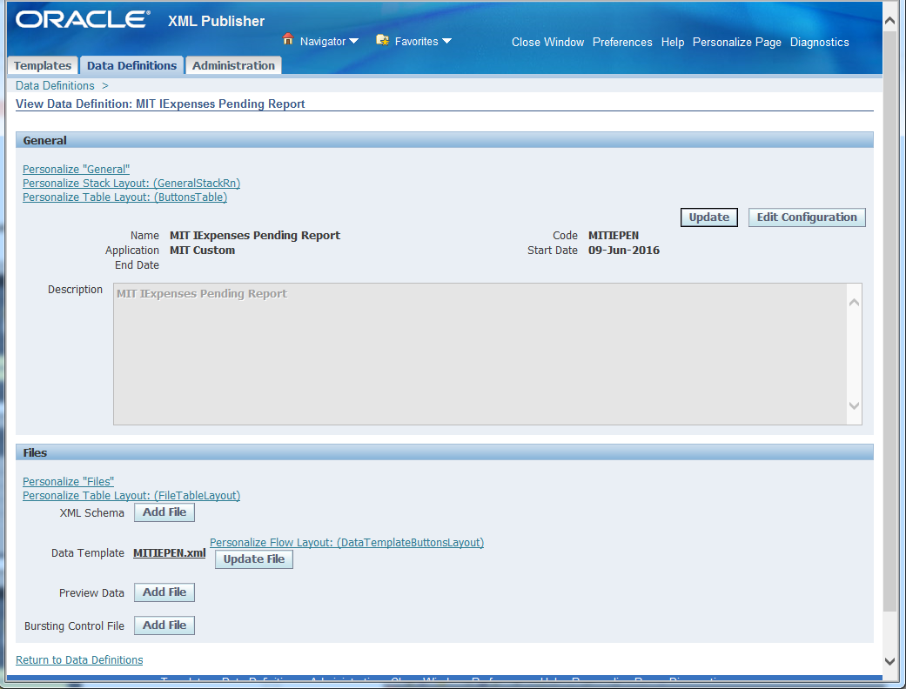

Define XML Template
Responsibility: XML Publisher
Menu Path: Home -> Templates
Form: Templates
Purpose: Define the Layout Template; attach the RTF Report Template file.

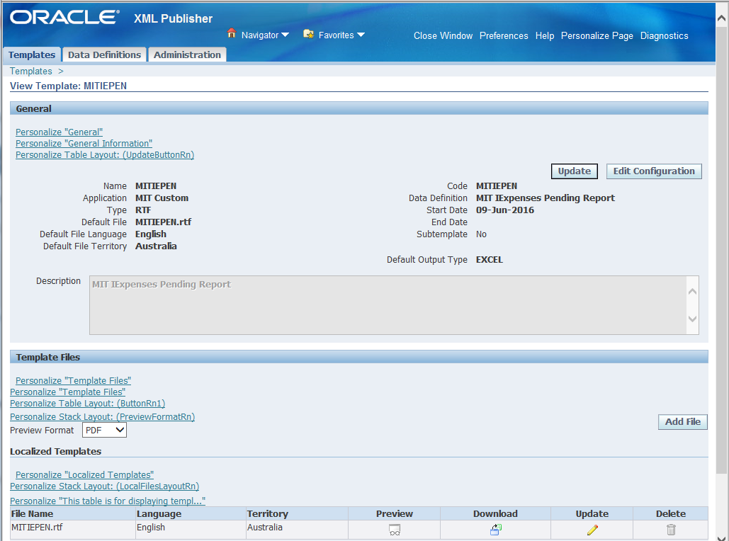

Update Concurrent Program
Responsibility: System Administration
Menu: Concurrent -> Program
Form: Concurrent Program
Purpose: Update the Operating Unit mode to Multiple.
Note: This can only be done in the HTML version of this program via the System Administration responsibility, not the System Administrator responsibility.

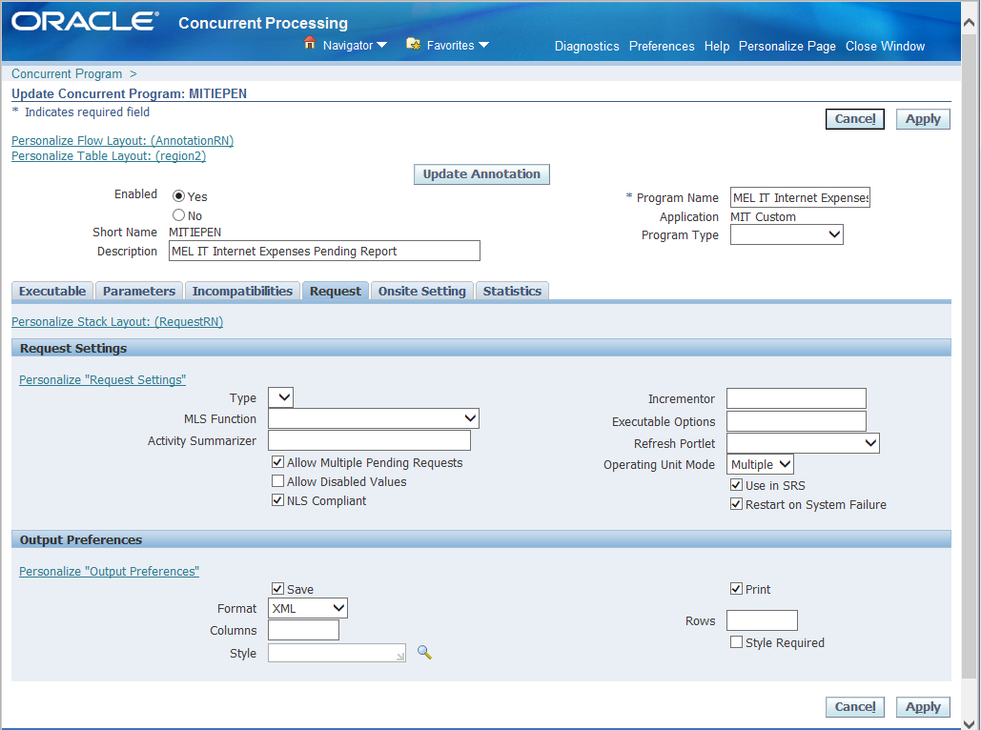

Update Request Group
Responsibility: System Administration
Menu Path: Security-> Responsibility -> Define
Form: Request Group
Purpose: Add the Report to the Payables Request Group
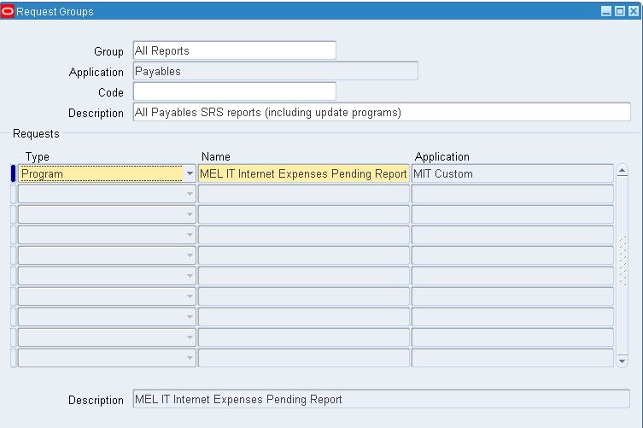

Report Execution

- Login to your Payables Responsibility and execute the Concurrent Requests program.

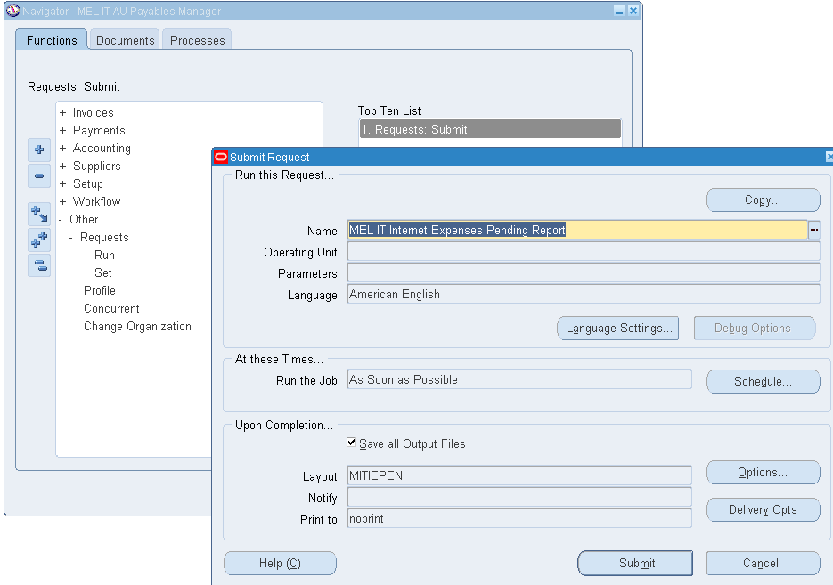

- Enter MEL IT Internet Expenses Pending Report as the Name. Submit the Report.
- Execute the View -> Requests menu.
- Click the View Output button in OFC Requests form
- Click the Save option in the Internet Explorer window. This will save the report in your standard Downloads folder.
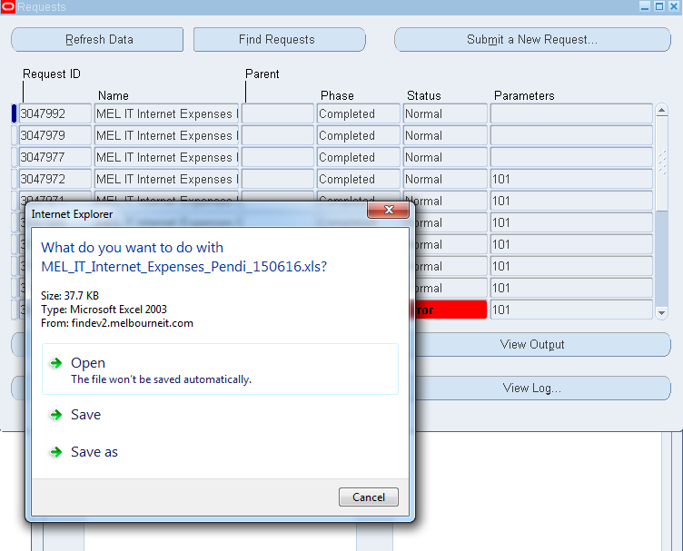
- Navigate to your Downloads folder and open the report file.

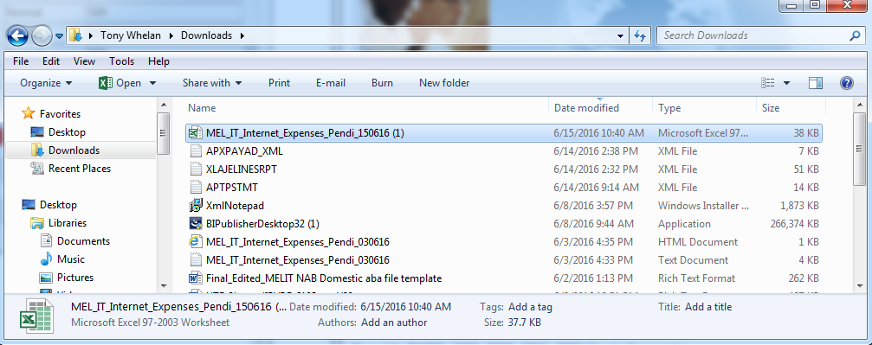

- The report will be displayed in Excel format.
- Click ‘Yes’ to ignore the file format extension warning due to different versions of Excel between OFC and MIT.
- The report output will be displayed in Excel format.

